Lab 3
Name : Alveena naz
Reg No. FA25-BSE-010

Lab task 1:
// main class
public class JavaApplication12 {
public static void main(String[] args) {
Marks m1 = new Marks();
m1.setMarks1(91);
m1.setMarks2(80);
m1.setMarks3(70);
System.out.println("Marks 1 is " + m1.getMarks1());
System.out.println("Marks 2 is " + m1.getMarks2());
System.out.println("Marks 3 is " + m1.getMarks3());

}

}
// Marks class
public class Marks {
private int marks1;
private int marks2;
private int marks3;
Marks(){}
Marks(int m1,int m2,int m3)
{
this.marks1 = m1;
this.marks2 = m2;
this.marks3 = m3;
}
public void setMarks1(int m1)
{
marks1 = m1;

}
public void setMarks2(int m2)
{
marks2 = m2;
}
public void setMarks3(int m3)
{
marks3 = m3;
}
public int getMarks1()
{
return marks1;
}
public int getMarks2()
{
return marks2;
}
public int getMarks3()
{
return marks3;
}
}

OUTPUT:
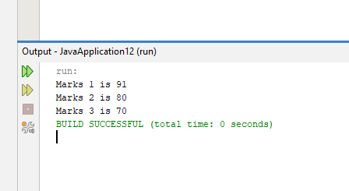

Task 2:
//main class
public class JavaApplication13 {
public static void main(String[] args) {
Account acc1 = new Account();
acc1.setBalance(5000);
acc1.deposit(1000);
acc1.withdraw(500);
System.out.println("Your new balance is " + acc1.getBlanace());
Account acc2 = new Account();
acc2.setBalance(8000);
acc2.deposit(1000);
acc2.withdraw(500);
System.out.println("Your new balance is " + acc2.getBlanace());

}

}

// account class
public class Account {
private int balance;
Account(){}
Account(int b)
{
this.balance = b;
}
public void setBalance(int b)
{
balance = b;
}
public int getBlanace()
{
return balance;
}
public void deposit(int money)
{
balance+=money;
}
public int withdraw(int money)
{
balance-=money;
return balance;
}

}

OUTPUT:

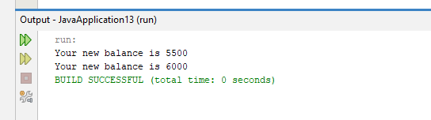

Task 3:
// main method
public class JavaApplication14 {
public static void main(String[] args) {
int result1[] = {67,89,90,34,45};
int result2[] = {45,89,78,34,87};
Student s1 = new Student();
s1.setName("alveena");
s1.setResult(result1);
s1.display();
double avg1 = s1.average();
Student s2 = new Student();
s2.setName("lavizah");
s2.setResult(result2);
s2.display();
double avg2 = s2.average();
// compare both student averages
if(avg1>avg2)
System.out.println("Student 1 has greater average");
else
System.out.println("Student 2 has greater average");
// student 3
Student s3 = new Student(s1.getName(),s2.getResult());
s3.display();

}

}
//Student class
public class Student {
private String name;
private int result[];
Student(){}
Student(String n , int[] r)
{
this.name = n;
this.result = r;
}
public void setName(String n)
{
name = n;
}
public String getName()
{
return name;
}
public void setResult(int[] r)
{
result = r;
}
public int[] getResult()
{
return result;
}
public double average()
{
double avg =0;
int total =0;
for(int i =0;i<result.length;i++)
{
total+=result[i];
}
avg = total/result.length;
return avg;
}
public void display()
{
System.out.print(name + " ");
for(int i=0;i<result.length;i++)
{
System.out.print(result[i] + " ");
}
System.out.println();
}

}
OUTPUT:
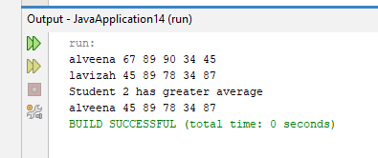

Lab task 5:
//main class
public class JavaApplication15 {
public static void main(String[] args) {
HotDogsStand h1 = new HotDogsStand(101,3);
System.out.println("Hot dogs sold " + h1.getSold());
HotDogsStand h2 = new HotDogsStand(102,4 );
System.out.println("Hot dogs sold " + h2.getSold());
HotDogsStand h3 = new HotDogsStand(103,6);
System.out.println("Hot dogs sold " + h2.getSold());
}

}
// hot dog class
public class HotDogsStand {
int id;
private int sold;
HotDogsStand(){}
HotDogsStand(int id,int sold)
{
this.id = id;
this.sold= sold;
}
public int getSold()
{
return sold;
}
public void justSold()
{
sold++;
}
public void display()
{
System.out.println("ID: " + id);
System.out.println("Hot dogs sold " + sold);
}

}
OUTPUT:
